**Final Capstone Project Proposal _ Mohammad Yousuf Mehraban**

**Project Name: Movie Radar**

Movie Radar application will give users the ability to search and find out which streaming platform such as Netflix, Hulu, Disney+, HBO, Amazon-Prime, YouTube and etcetera streams the movie or TV-show that they would like to watch; instead of searching each individual streaming service separately.

The user can create, edit and delete a playlist or add their favorite movies and TV-show to their favorite playlist. The user can also create a watched-playlist to add all of the movies he has already watched and a recommendation-list to recommend and share the movie they like with their friends and others.

APIs: I would like to use two free APIs including WatchMode and OMDB APIs.

API websites: <https://api.watchmode.com> and <https://www.omdbapi.com>

Authentication: Users authentication uses JSON Web Token, and backend form validation JSONSchema.

1. **What tech stack will you use for your final project?**

I will mainly use Node.js, Express.js, SQL and PostgreSQL in the backend; and React, Bootstrap, Reactstrap, HTML, and CSS in the frontend.

1. **Is the front-end UI or the back-end going to be the focus of your project?**

I would like to build an evenly focused full-stack application. Both backend and frontend are at my focus.

1. **Will this be a website? A mobile app? Something else?**

This will be a website.

1. **What goal will your project be designed to achieve?**

When I want to watch a movie or a TV show, at first, I don’t know either Netflix, HBO or Amazon Prime, or what streaming service has my intended movie. Sometimes it takes me a while to find out the streaming service which has that movie or TV show. Therefore, I build this website or application to help anyone like me to quickly find out what streaming service has their intended move or TV show instead of searching each steaming platform separately.

1. **What kind of users will visit your app? In other words, what is the demographic of your users?**

Movie Radar app doesn’t have a specific demographic, anyone interested in movies and TV shows, who would like to quickly find out on what streaming platform to watch a movie or TV show, will visit and use this app.

1. **What data do you plan on using? How are you planning on collecting your data?**

I would like to use two free APIs including WatchMode and OMDB APIs.

API websites: <https://api.watchmode.com> and <https://www.omdbapi.com>

If I cannot get all the data I require for my application from the mentioned two APIs, I would use IMDB and maybe some other API as well.

1. **In brief, outline your approach to creating your project Answer questions like the ones below, but feel free to add more information:**
2. **What does your database schema look like?**

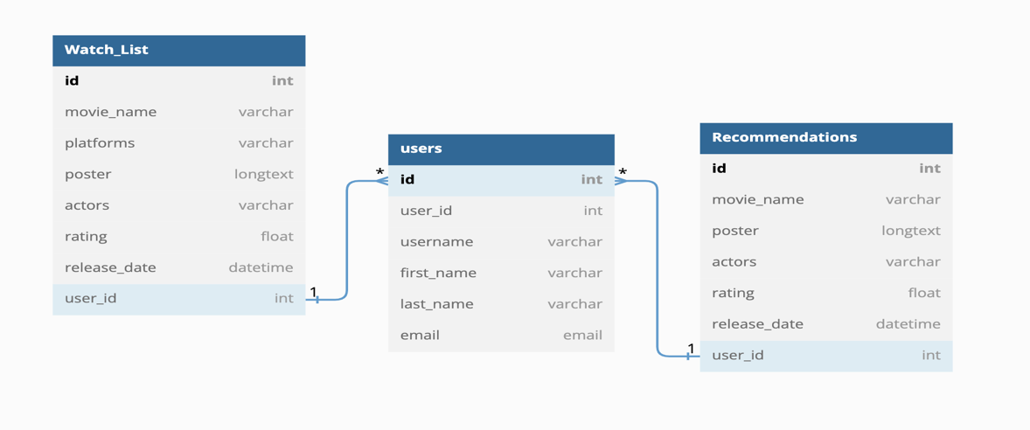

1. **What kinds of issues might you run into with your API?**

As I mentioned, If I cannot get all the data I need for my application from the above-mentioned APIs, I would look for other APIs such as IMDB which is paid.

1. **Is there any sensitive information you need to secure?**

Yes, I would like to secure my API key, application secret key and also the users’ credentials. Users must register or login to use the application. Therefore, securing users’ credentials are my top priority.

1. **What functionality will your app include?**

The web application will have login and registration forms. After a successful registration or login, users can access the full feature, which includes but not limited as of now: 1. a search bar where users type a movie or TV show name to search, 2. after the search, movie name, movie poster, release date, movie length, actors will be displayed, and a list of all streaming platform that streams that movie or TV show will be provided so the user can decide what platform to pick. At the end of the movie information, I would like to add a link button, in case if users would like to know more about a movie or TV show such as movie director award nomination, IMDB rating, language, box office and more.

In addition, users can create different Lists, such to-watch-list, recommendation-list and etcetera where they add their favorite movies or TV shows.

1. **What will the user flow look like?**

At first, users should login or signup to use the application, and after a successful login users can search and know about any movie the love and want to watch.

1. **What features make your site more than a CRUD app? What are your stretch goals?**

Other than CRUD, I would like to use authentication using JSON Web Token and backend form validation using JSONSchema. I currently don’t have any specific stretch goal, but maybe I would add a few during the project workflow.